Flow of authentication

Question:How the authentication is happens,once te username and
password submitted throught login form(abstract flow)

1-Client

2-Authentication filter(this will create authentication Object)

3-Authentication Object(this object pass thought the whole app and
final destination is security Context(session))

4-Authentication manager

5-Authentication provider
->User Details
->PasswordEncoder

6-SecurityContext (this will communicate with the authentication filter)

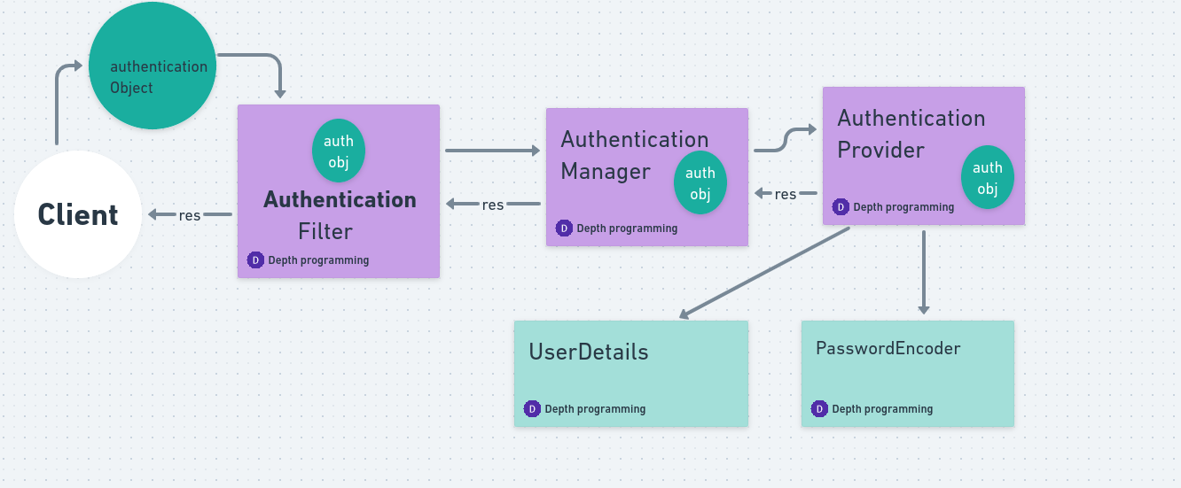

In Last Context Holder is Connected to Authentication Filter and authenticated Object store inside of Context Holder when same user is coming again no need to authenticated same Object
Important point :Bydefault spring is activating and prviding
two kind of Authentication
->Form based authentication
->basic authentication
Form based authentication:spring check whether the request is comming
from web browser it is using form based authentication

basic authentication:whether the request is comming from REST Client
like e.g Postman it is using basic authentication

Question:where spring security is activating these two filters

Whenevere we providing the security we are using this class
webSecurityConfigurerAdapter
like e.g
class MySecurityConfig extends webSecurityConfigurerAdapter
{
//security code

}

this class will create these two filter

Inside of this class one method is configure inside of this

http.authorizeRequest()
.anyRequest().authenticated()
.and()
.formLogin().and()
.httpBasic(); → with the help of this we are able to perform Basic authentication

this means any request that is coming from web browser to my server make it authenticated and create those two filters

Note:Basic authentication is not a good practice because it is not secure

denyAll() instead of authenticated() method kisi request ko b accept na karo

permitAll() subrequest ko accept karo

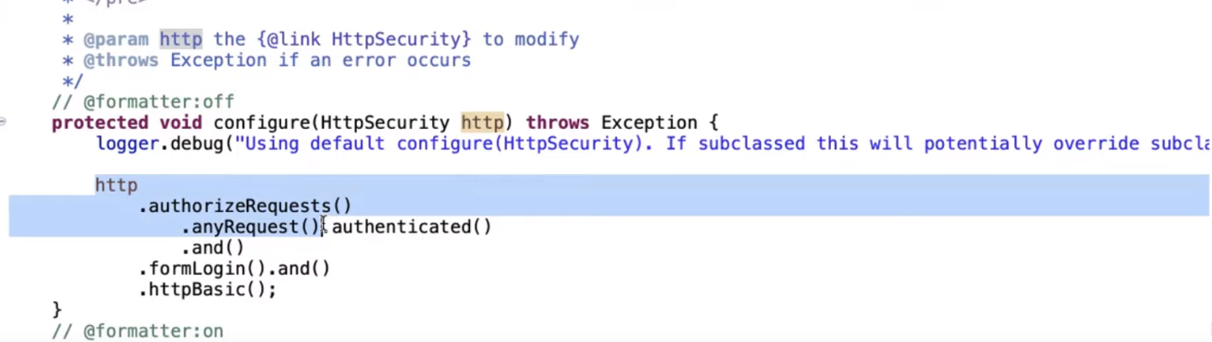

we can use custome logout
step 1:create custome logout and configure in this method by using logout method

2-we can handle error conditon in jsp page provide this condition using jstl
<c:if test =”{param.error!=null}”>
<h3>invalid username and password</h3>

</c:if>

<c:if test =”${logout==null}”>
<h3>you have successfully logout Please sign in again</h3>
</c:if>

IMPORTANT NOTE:

We cannot provide any action and method in custome login form how spring getting the username and password

Spring handling automatically by default method is always post and also action is auto generated
yes we can change the this action by using configure method inside of this method use login processing URL

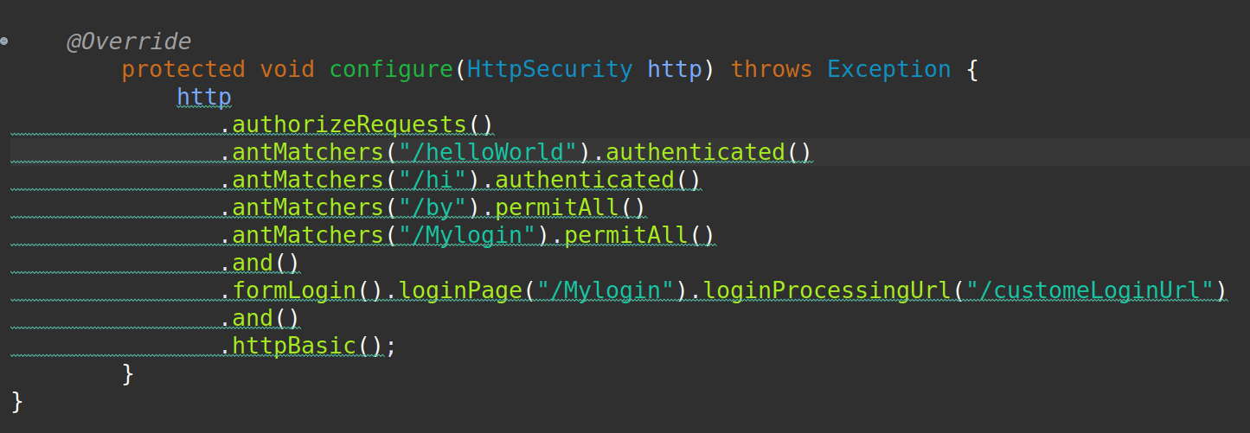

What is CSRF (Cross-Site Request Forgery):
what is CSRF Token: A CSRF token (Cross-Site Request Forgery token) is a security measure used to mitigate the risk of Cross-Site Request Forgery (CSRF) attacks. CSRF tokens are unique, unpredictable values that are included in requests to prove that the request is legitimate and not generated by an attacker

In Spring security when we submit the form spring create CSRF Token automatically created
if I want to see this token just right click in Browser and click inspect
if I want to disable token we can do that

Practical to disable CSRF Token

Inside of configure method
public void configure(HttpSecurity security……………..)
{
http.csrf.disable();
}

1-Understanding CSRF Attack ?

Attacker Create fake website with the help of this hacker attack over website

2-How to protect your website from CSRF Attack ?

→ Spring security automatically provided csrf protection

